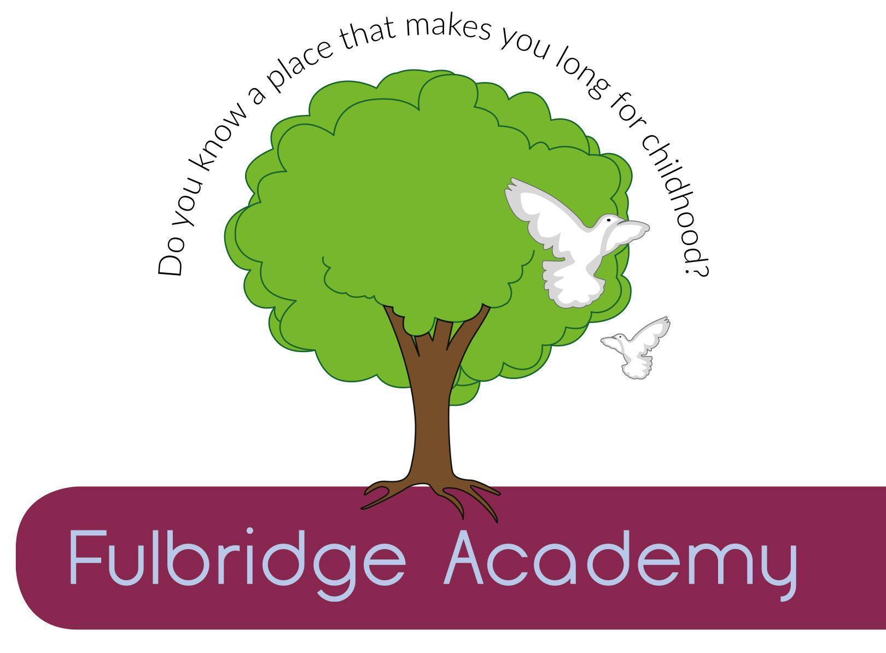

Person Specification
Cleaner

The Four Cs MAT is committed to safeguarding and protecting the welfare of children and young people and expects all staff and volunteers to share this commitment. All appointments involve regulated activity and are subject to an Enhanced DBS disclosure and two successful references. Online searches are carried out on all shortlisted candidates.

 | Essential | Desirable
Qualifications

No specific educational qualifications are required
Experience |  | - Experience of general cleaning activities
Knowledge and Understanding | - Willingness to maintain confidentiality on all school matters  - Willing to undertake training courses that are relevant to the duties of the post or are required for Health and Safety reasons
Personal Attributes | - Willingness to work flexible hours on occasions  - Good time keeper  - Works well in a team  - Trustworthy and reliable

Skills | Able to undertake a range of manual cleaning activities  Ability to maintain high standards of cleanliness in accordance with specified rotas  Ability to work in an organised and methodical manner  Ability to able to use own initiative  Ability to work effectively and supportively as a member of the school team  Ability to take personal responsibility for standard of work carried out

